Name ______________________________ Date __________

captive (adjective)

Word in Context: Many scientists are finding out more about the chimpanzee mind from tests in captive situations. For example, chimps will go and find sticks to pull in food that has been placed outside the cage, beyond their reach.
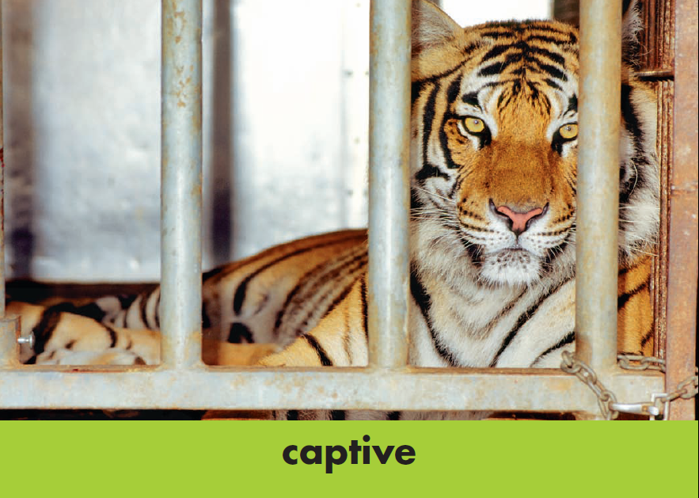

Definition: ______________________________________________
_______________________________________________________

Write in a SIMPLE Sentence with a Possessive Noun: _____________
______________________________________________________________________________________________________________

Synonyms:
- _____________________________
- _____________________________

companionship (noun)

Word in Context: Animal welfare groups are trying to raise the money to build them sanctuaries, so that they can end their lives with grass and trees, sunshine and companionship.
Definition: ______________________________________________
_______________________________________________________

Write in a COMPLEX Sentence (*Hint—AAAWWUBBIS): _______________________________________________________
______________________________________________________________________________________________________________

Synonyms:
- _____________________________
- _____________________________
existence (noun)

Word in Context: The young chimpanzee was shipped away from his forest world to the cold, bleak existence of a North American research lab.
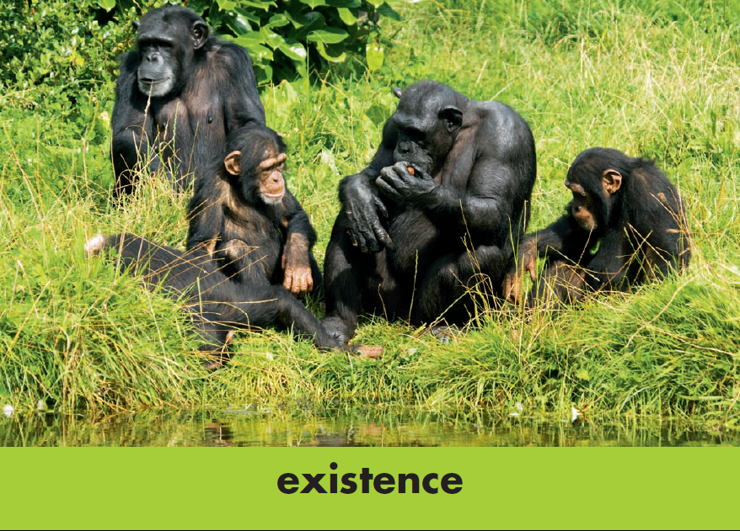

Definition: ______________________________________________
_______________________________________________________

Write in a COMPOUND Sentence (*Hint— , FANBOYS): _______________________________________________________
______________________________________________________________________________________________________________

Synonyms:
- _____________________________
- _____________________________
ordeal (noun)

Word in Context: A young male called Ham was sent up into space. He was shot up in a Mercury Redstone rocket in January 1961, and because he survived the ordeal (he was terrified), it was decided that it was safe for the first human astronauts.
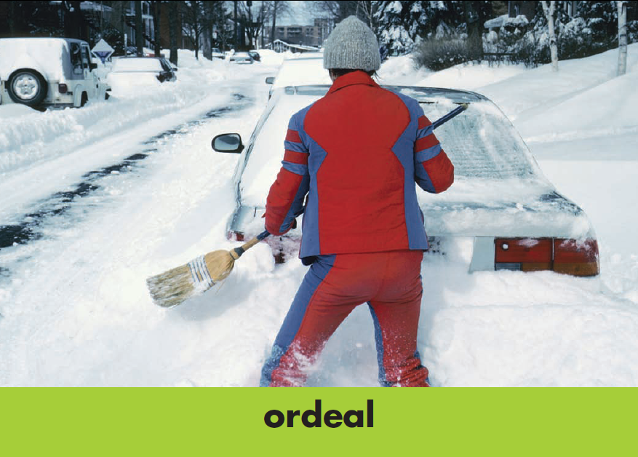

Definition: ______________________________________________
_______________________________________________________

Write in a SIMPLE Sentence with a Possessive Noun: _____________
______________________________________________________________________________________________________________

Synonyms:
- _____________________________
- _____________________________
primitive (adjective)

Word in Context: It seems that infant chimps learn these behaviors by watching the adults, and then imitating and practicing what they have seen. So the chimps have their own primitive culture.
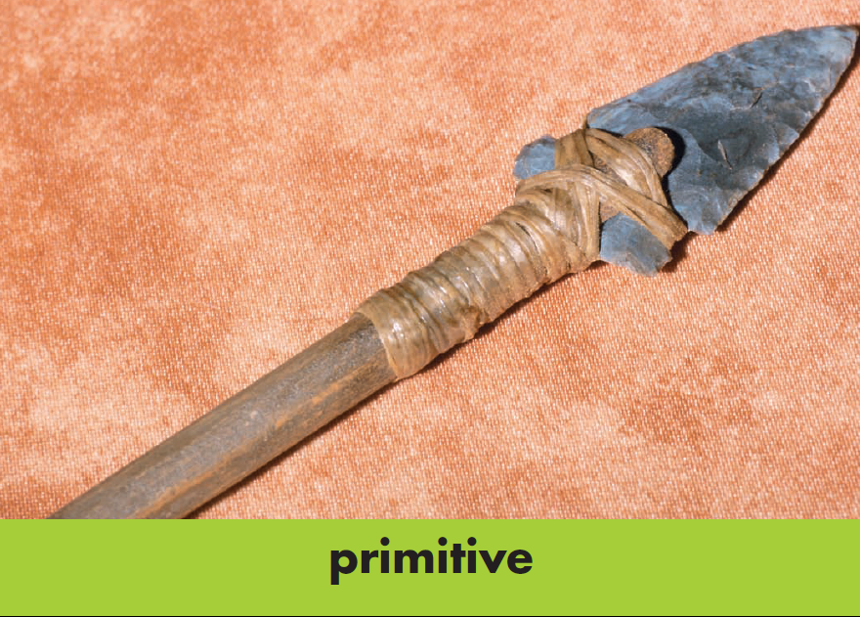

Definition: ______________________________________________
_______________________________________________________

Write in a COMPLEX Sentence (*Hint—AAAWWUBBIS): _______________________________________________________
______________________________________________________________________________________________________________

Synonyms:
- _____________________________
- _____________________________
sanctuaries (noun)

Word in Context: Animal welfare groups are trying to raise the money to build them sanctuaries, so that they can end their lives with grass and trees, sunshine and companionship.
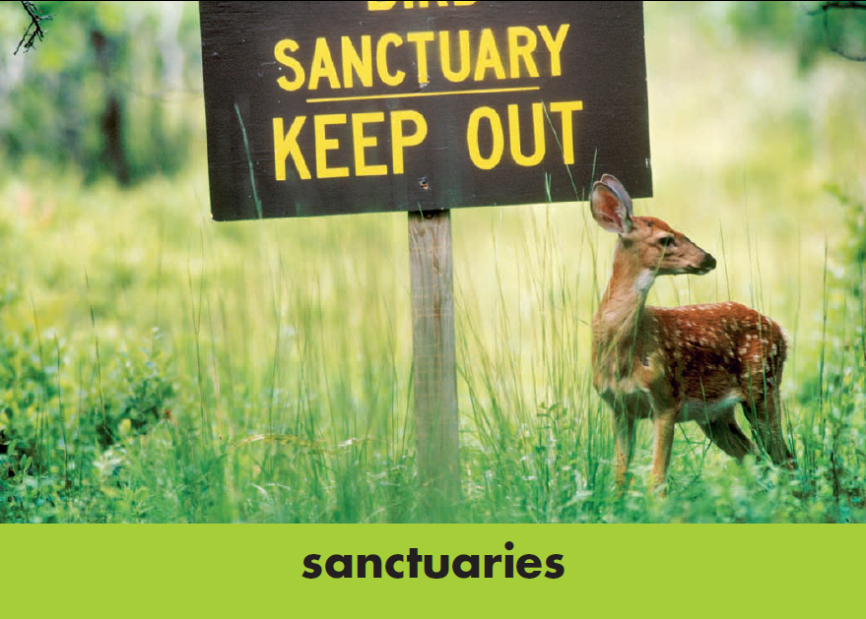

Definition: ______________________________________________
_______________________________________________________

Write in a COMPOUND Sentence (*Hint— , FANBOYS): _______________________________________________________
______________________________________________________________________________________________________________

Synonyms:
- _____________________________
- _____________________________

stimulating (adjective)

Word in Context: Good zoos keep their chimpanzees in groups and provide them with all kinds of stimulating things to do, different things each day, so that they don’t get bored.
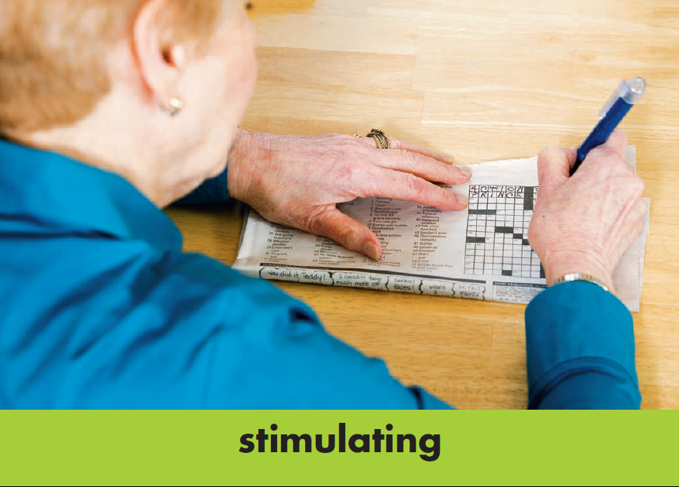

Definition: ______________________________________________
_______________________________________________________

Write in a SIMPLE Sentence with a Possessive Noun: _____________
______________________________________________________________________________________________________________

Synonyms:
- _____________________________
- _____________________________

